**TRIBHUWAN UNIVERSITY**

**INSTITUTE OF MEDICINE**

**POKHARA NURSING CAMPUS**

**RAMGHAT-12, POKHARA**

**Lesson Plan on: Human immunodeficiency Virus**

**Submitted to: Submitted by:**

Respected madam, Sushmita Gurung

Saphalta Shrestha Roll no: 23

Lecturer BNS 2nd year

BNS 1st year

Lesson plan on Human immunodeficiency Virus

|  |
| --- |
| Name of student teacher: Sushmita Gurung |
| Subject: Adult Health Nursing I |
| Unit: Common health problem of young Adult |
| Topic: Physical problem (Human Immunodeficiency Virus) |
| Date: 2079- 11- |
| Venue: BNS 1st year |
| Time: |
| Duration: 1 hour |
| Number of participants: 38 |
| Level of participants: BNS 2nd year |
| Language: English + Nepali |
| Teaching/ Learning method: Brainstorming, interactive lecture, Discussion |
| Teaching, Learning media: PowerPoint, Whiteboard, poster |
| Name of supervisor: Respected madam,  Saphallta Shrestha |

**General Objective:**

At the end of teaching session, BNS 1st year student will be able to describe about Human Immunodeficiency Virus.

|  |  |  |  |  |  |  |  |  |
| --- | --- | --- | --- | --- | --- | --- | --- | --- |
| **SN**  1.  2.  3.  4.  5.  6.  7. | **Specific objectives**  At the end of the teaching session, participants will be able to:  introduce  HIV  state the types of HIV  enlist the etiology and risk factors of HIV  enlist the mode of transmission of HIV  classify HIV according to WHO  enumerate the different clinical manifestation of HIV  discuss different diagnostic test of HIV | **Content**   * Greetings * Introduction   . self  . topic  . objectives  . pretest  Introduction of HIV  Types of HIV  Etiology and risk factors of HIV  Mode of transmission of HIV  Classification of HIV according to WHO  Clinical manifestation of HIV  Diagnostic test of HIV | **Time**  3 min  2 min  2 min  3 min  5 min  5 min  5 min  10 min | | **Teaching/**  **Learning**  **Method**  Brainstorming  Question Answer  Interactive lecture  Interactive lecture  Interactive lecture+ discussion  Interactive lecture+ discussion  Lecture  Interactive lecture  Interactive lecture+ discussion | | **Teaching/ Learning**  **media**  picture  PowerPoint  Poster  PowerPoint  PowerPoint  PowerPoint  PowerPoint  PowerPoint | **Evaluation**  What do you know about HIV?  What is HIV?  What are the types of HIV?  What are the etiology and risk factors of HIV?  What are the mode of transmission of HIV?  What are the classifications of HIV according to WHO?  What are the clinical manifestations of HIV?  What are the diagnostic tests for HIV? |
| 8.  9.  10. | Discuss medical and nursing management of HIV  State the preventive of HIV  Summary of topic | Medical and nursing management  Preventive measures of HIV  Summarization  References  Question  Home assignment  Plan for next class | 15 min  5 min  3 min  1 min  1 min | Interactive lecture  Interactive lecture + discussion | | PowerPoint  PowerPoint | | What are the management for HIV?  what are the preventive measures of HIV? |

**UNIT: 4.1 Common health problem of young adult**

* **Physical problem;**
* Accidents
* HIV
* Hepatitis
* Tuberculosis
* Sub-fertility
* Pregnancy related complication
* **Psychosocial problem;**
* Substance abuse
* Suicide
* Homicide
* Depression
* Divorce
* Singlehood
* Unmarried mother

**Young Adult**

Early adulthood or young adult extends from age 21 to 39 years old, when the physical growth is completed and psychological changes, which accompany by the beginning of the reproductive capacity.

It is the stage six of Erikson’s developmental stage.

The task is to achieve some degree of intimacy as opposed to remaining to isolation.

It includes not only the love we find in a good marriage, but the love between friends and the love of one’s neighbor, co-worker, and compatriot as well.

**Human Immunodeficiency Virus (HIV)**

**Introduction:**

The Human Immunodeficiency Virus (HIV) is an acquired infection in which the HIV integrates itself into CD4 ( helper T4) cells, causing severe immune dysfunction.

HIV infection renders the person unusually susceptible to other life-threatening infections and malignancies.

In its most serious form, HIV results in acquired immunodeficiency syndrome(AIDS)

**Epidemiology**

Global HIV epidemic, 2021 by World Health Organization

Total people living with HIV in 2021 is 38.4 million, people acquiring new HIV in 2021 is 1.5 million and people dying from HIV related causes in 2021 is 650,000.

Among them 36.7 million adult are living with HIV, 1.3 million acquired HIV in 2021 and 560,000 died from HIV.

Nepal

According to National Center for AIDS and STD control (NCASC)

Estimated number of people living with HIV is 29,503 in 2019.

In which 19,520 adults (15-49years) are infected in 2019.

**Types of HIV**

1. HIV type 1
2. HIV type 2

HIV Type 1

* Most common type in worldwide.
* Responsible for majority of HIV infection cases
* Usually progress to AIDS within 10 years.

HIV type 2

* Found primarily in West Africa and also in European countries.
* Less Virulent, doesn’t tend to progress to aids as quickly as type 1.

**Causative agent:** retrovirus (belonging the lentivirus subfamily)

**Risk factors**

* Age
* Sex: Male>Female(2:1)
* Occupation: Sex worker, Health care providers, lab personnel.
* Disease condition: sexually transmitted disease(STI) such as syphilis, herpes, chlamydia, gonorrhea.
* Human factors:
* sexual practices (unprotected sex, multiple sex partner,

anal or oral sexual activity, open sores/lesions/irritation in genital area)

* perinatal exposure (during pregnancy, birth, breast feeding)

**Mode of transmission:**

HIV is a fragile virus. It can only be transmitted under specific condition that allows contact with infected body fluids including blood, semen, vaginal secretions, and breast milk.

HIV infected individuals can transmit HIV to others within a few days after becoming infected. After that, the ability to transmit HIV is lifelong.

Transmission of HIV is subject to same requirements as other microorganisms.

Duration and frequency of contact, volume of fluid, virulence and concentration of the organism and host immune status all affect whether infection is established after an exposure.

HIV is not spread casually. The virus cannot be transmitted through hugging, dry kissing, shaking hands, sharing eating utensils, using toilet seats or attending school or working with an HIV infected person

It is not transmitted through tears, saliva, urine, emesis, sputum, feces or sweat.

HIV mode of transmission are:

* Sexual transmission: unprotected sexual contact with an HIV infected partner is the most common mode of transmission. Sexual activity provides an opportunity for contact with semen, vaginal secretions or blood, all of which have lymphocytes that may contain HIV.

Heterosexual has become most common method of infection for women.

During any form of sexual intercourse (anal, vaginal or oral), the risk of infection is greater for the partner who receives the semen, although infection can also transmitted to an inserting partner.

Sexual activities that involve blood, such as menstruation/trauma, lesion by other sexually transmitted disease( herpes, syphilis) significantly increases the likelihood of infection.

* Contact with Blood and Blood products: HIV can be transmitted during exposure to blood through drug using equipment.

Puncture wounds are the most common means of work related transmission.

The risk of infection is 0.3% to 0.4% (3 to 4 out of 1000) after needle stick exposure.

The risk is higher if the exposure involves blood from a patient with high viral load, deep puncture wound, needle with hollow bore and visible blood, device used for arterial or venous or a patient who dies within 60 days.

Splash exposures of blood on skin with an open open lesion present some risk but it is much lower than from puncture wound.

* Perinatal transmission: most common route of infection for children.

Transmission from an infected HIV-infected mother to her infant can occur through pregnancy, at the time of delivery or after birth through breastfeeding.

On average, 25% of infants born to untreated HIV-infected women will be born with HIV.

This means that 75% of these infants would not have been infected even without treatment.

**Clinical staging of HIV**

**WHO Clinical Staging System of HIV**

|  |  |
| --- | --- |
| **HIV- Associated Symptoms** | **WHO clinical stage** |
| Asymptomatic | 1 |
| Mild symptoms | 2 |
| Advanced symptoms | 3 |
| Severe symptoms | 4 |

Clinical Stage 1 – Asymptomatic

* No HIV related symptoms and no signs on examination.
* Persistent generalized lymphadenopathy ( painless enlarged lymph nodes >1cm in two or more non-contiguous sites excluding inguinal in the absence of known cause and persisting for three months or more.

Clinical Stage 2 – Mild symptoms

* Unexplained moderate weight loss (<10% of presumed or measured body weight)
* Recurrent respiratory tract infection (sinusitis, tonsilitis, otitis media and pharyngitis)
* Herpes Zoster
* Angular cheilitis
* Recurrent oral ulceration
* Papular pruritic eruptions
* Seborrheic dermatitis
* Fungal nail infections

Clinical stage 3 – Advanced symptoms

* Unexplained severe weight loss (10% of presumed or measured body weight)
* Unexplained chronic diarrhea for longer than one month.
* Unexplained persistent fever (above 37.5 degree Celsius intermittent or constant, for longer than one month)
* Persistent oral candidiasis
* Oral hair leukoplakia
* Pulmonary tuberculosis
* Severe bacterial infections (pneumonia, empyema, pyomyositis, meningitis or bacteremia)
* Acute necrotizing, ulcerative stomatitis, gingivitis or periodontitis
* Unexplained anemia (<8 g/dl), neutropenia (<0.5 x 109/l), and/or chronic thrombocytopenia (<50 x 109/l).

Clinical Stage 4 – severe symptoms

* HIV-wasting syndrome
* Pneumocystis pneumonia
* Chronic herpes simplex infection (genital or anorectal) for more than one month or visceral at any site.
* Esophageal candidiasis
* Extra pulmonary tuberculosis
* Kaposi’s sarcoma
* Cytomegalovirus infection
* HIV encephalopathy
* Recurrent septicemia
* Lymphoma (cerebral or non-Hodgkin)
* Symptomatic HIV-associated nephropathy or symptomatic HIV-associated cardiomyopathy.

**Clinical features**

* Primary infection (Acute HIV)
* Clinical latent infection (Chronic HIV)
* Symptomatic HIV infection
* Progress to AIDS

Primary Infection (Acute HIV)

* Develop a flu like illness within 2 to 4 weeks after the virus enter the body.
* Sign and symptoms
* Fever
* Headache
* Muscle ache and joint pain
* Rashes
* Sore throat and painful mouth sores
* Swollen lymph glands, mainly on the neck
* Diarrhoea
* Weight loss
* Cough
* Night sweats

Clinical latent infection (chronic HIV)

* In this stage of infection, HIV is still present in the body and in white blood cells. However, many people may not have any symptoms or infection during this time.
* This stage can last for many years if you are not receiving antiretroviral therapy (ART). Some people develop more severe disease much sooner

Symptomatic HIV infection

* As the virus continues to multiply and destroy your immune cells. People may develop mild infections or chronic signs and symptoms such as
* Oral yeast infection
* Shingles (Herpes Zoster)
* Vaginal candidiasis
* Pneumonia
* Dry skin with lesions

Progression to AIDS

* Sign and symptoms are:
* Sweats, chills
* Chronic diarrhoea
* Swollen lymph nodes
* Persistent white spots or unusual lesions on your tongue or in your mouth
* Persistent, unexplained fatigue, weakness
* Skin rashes, weight loss
* Peripheral neuropathy

**Diagnosis**

* + History Taking
  + Physical Examination
  + Laboratory investigation:
* **Antibody Assays**:
* measures the immune system’s response from exposure to a specific antigen.
* It depends on antibody formation but a patient’s serum may not have detectable level of antibody during initial stage of infection.
* Newborns maintain the maternal antibodies for as long as 18 months; therefore, antibody testing is unreliable until the infant is 18 months of age.
* **Enzyme-linked Immunosorbent Assay (ELISA):**
* Highly specific test that is close to 99.6% sensitive for HIV-1 antibodies.
* If serum is reactive, the patient is considered seropositive for HIV antibodies.
* False positive are possible if it is from recent influenza, hepatitis B vaccines, multiparous women with multiple blood transfusion or multiple myeloma, alcoholic hepatitis.

* **Western Blot test:**
* If ELISA came positive then it is confirmed by Western Blot technique, another more sensitive test for HIV-1 antibodies.
* Like ELISA it relies on the production of antibodies and may not detect antibodies during early stage of infection.
* **Rapid tests:**
* Rapid HIV antibody test are being more widely used because of ease of use and convenience.
* Many have comparable sensitivities to the ELISA and Western Blot.
* **Viral Load:**
* Measured periodically in HIV positive persons to assess their disease progression and to monitor the effectiveness of antiretroviral therapy.
* It is aimed at reducing plasma HIV RNA level of below the limit of detection by assay.
* **CD4 Cell Counts:**
* Measure the extent of immune damage that has occurred as a result of HIV infection and it’s complication.
* CD4 cell counts are obtained on newly diagnosed patients to establish a baseline and every 3 to 4 months thereafter if counts are above 350/ mm and the patient is asymptomatic and not receiving any drug therapy.
* Once drug is initiated, counts are monitored every 2 to 4 weeks initially and every 3 to 4 months if the patient is stabilizes.
* CD4 cell counts are used in conjunction with viral load to predict the possibility of disease progression, determine when to start antiretroviral therapy, and monitor the effectiveness of treatment.
* Patients with plasma HIV RNA levels of less than 7000 copies/ml and CD4 counts greater than 350/mm have less than a 2% likelihood of progressing to AIDS within 3 years without treatment.

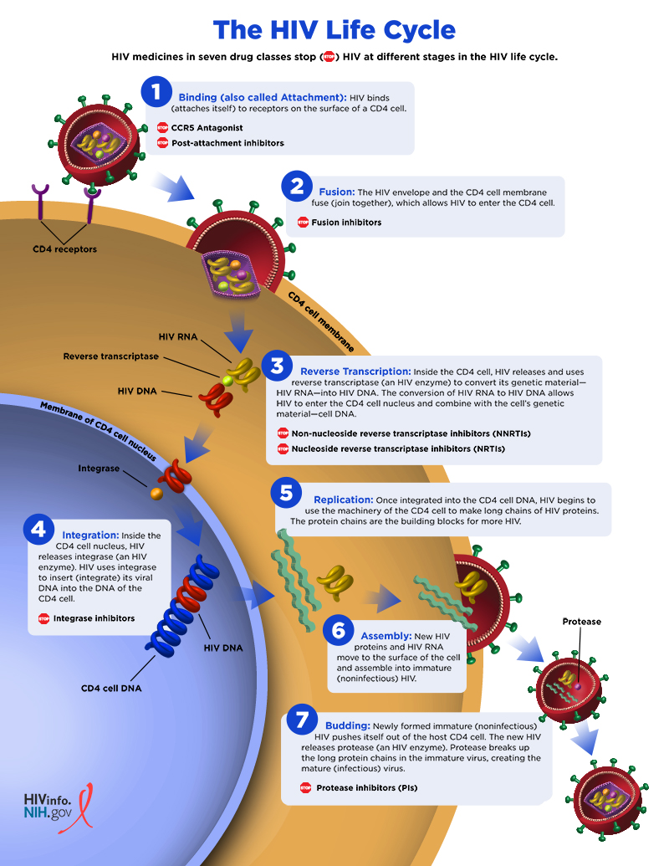

**Treatment: Antiretroviral therapy**

* Nucleoside Reverse Transcriptase Inhibitors (NRTI): Zidovudine, Lamivudine, Abacavir
* Nucleoside Analogue Reverse Transcriptase inhibitor (NtRTI): Tenofovir
* Non-Nucleoside Reverse Transcriptase Inhibitors (NNRTI): Efavirenz, Nevirapine
* Protease inhibitor (PI): Atazanavir, Indinavir, Lopinavir/Ritonavir
* Fusion inhibitors: Enfuvirtide
* Integrase inhibitors: Raltegravir
* Chemokine Receptor Antagonists (CCr5 Antagonists): Maraviroc

**Special treatment**

* Tuberculosis: Anti-tubercular drugs
* Fungal infection: Anti-fungal drugs
* Bacterial infection: anti-bacterial drugs
* Pneumo-cystitis: Trimethoprim, Sulfamethoxazole
* Post exposure prophylaxis for accidental needle sticks involve treatment with transcriptase inhibitors
* Anti-diarrhoeal therapy, Nutritional therapy

**Nursing management**

Assessment

* Include identification of potential risk factors, including a history of sexual practices and IV/Injection drug use history.
* Assess physical and psychological status.

- Nutritional status:

* Dietary history
* Factors interfere oral intake, such as anorexia, nausea, vomiting, oral pain or difficulty in swallowing.
* Patient’s ability to purchase and prepare food
* Weight history (change over time)

- Skin and mucous membrane:

* Inspect daily for breakdown, ulceration and infection.

- Respiratory Status:

* Monitor for cough, sputum production, shortness of breath, orthopnea, tachypnea and chest pain.

- Neurological status:

* Assess level of consciousness, orientation to person, place and time
* Observe for sensory deficits such as visual changes, headache and numbness and tingling in the extremities.

- Fluid and electrolyte status:

* Examine skin and mucous membrane for turgor and dryness.
* Asses for dehydration (increased thirst, decreased urine output, low blood pressure, weak rapid pulse)
* Assess electrolyte imbalance through laboratory investigations.

- Level of knowledge:

* Assess the level of knowledge of friends and family regarding the transmission of disease.

Nursing Diagnosis

* Ineffective airway clearance related to increased bronchial secretions and decreased ability to cough related to weakness and fatigue.
* Acute pain related to impaired skin integrity secondary to diarrhea.
* Impaired skin integrity related to cutaneous manifestations pf HIV infection, excoriation and diarrhea.
* Risk for imbalance nutrition less than body requirement related to decreased oral intake.
* Risk for infection related to immunodeficiency.

Nursing Interventions

* Improving airway:
* Assess respiratory status, mental status and skin color.
* Note and document presence of cough and quantity and characteristics of sputum.
* Encourage adequate rest to minimize energy expenditure and prevent fatigue.
* Assist in positioning (high or semi-flower’s) that facilitates breathing and airway clearance.
* Provide pulmonary therapy; coughing, deep breathing, postural drainage, percussion and vibration every 2 hour to prevent stasis of secretion and promote airway clearance.
* Reliving pain and discomfort:
* Assess patient for quality and severity of pain associated with impaired perianal skin integrity and peripheral neuropathy.
* Communicate about exacerbating and relieving factors.
* Encourage to use soft cushions or foam pads while sitting and topical aesthetic or ointments as prescribed.
* Instruct to avoid irritating food.
* Use non pharmacologic approaches, such as relaxation technique.
* Administer non-steroidal anti-inflammatory agents as prescribed.
* Promoting skin integrity:
* Assess skin and oral mucosa for changes in appearance, location and size of lesions and evidence of infection, breakdown.
* Encourage for balance rest and mobility whenever possible; assist immobile patient to change position every 2 hours.
* Use device such alternating pressure mattress and low-air-loss beds.
* Encourage to avoid scratching, to use nonabrasive and non-drying soaps.
* Keep bed linen free of wrinkles and avoid tight or restrictive clothing to reduce friction to skin.
* Improving nutritional status:
* Assess weight, dietary intake.
* Instruct about ways to supplement nutritional value of meals (e.g., Add egg, milk)
* Based on assessment of factors interfering with oral intake, implement specific measures to facilitate oral intake.
* Control nausea and vomiting; eat easy to swallow food, encourage oral hygiene before and after meal.
* Do not schedule meals after painful or unpleasant procedures.
* Provide enteral or parenteral feeding to maintain nutritional status as indicated.
* Preventing infection:
* Instruct patient and care givers to monitor for signs and symptoms of infection.
* Monitor laboratory values that indicate the presence of infection such as white blood cell count.
* Maintain for aseptic technique for invasive procedures.

**Prevention**

* Screen all blood and blood products.
* Follow universal precaution
* Educate safer sex practice
* Identify and treat Sexually transmitted diseases
* Prevent the transmission from to child
* Post exposure prophylaxis
* Sharing of needles and shaving blades should not practiced

**Summary**

Human Immunodeficiency Virus (HIV) is an acquired infection in which HIV virus integrates itself to CD4 (helperT4) cells, causing severe immune dysfunction. HIV have two types HIV type 1 and HIV type 2 where HIV type 1 is the most leading cause for HIV infection. Sex worker, health care provider and people having sexually transmitted disease are highly at risk for HIV infection. HIV can be transmitted through contact with infected blood, unprotected sexual practices and perinatal exposer. HIV infected person can be asymptomatic to having symptoms such as fever, headache, swollen lymph glands, peripheral neuropathy. Diagnostic test like ELISA, Rapid test, Antibody assay etc can be for confirmation. HIV is not curable however, it can be controlled by HIV treatment such as anti-retroviral therapy. Symptomatic management can be done and prevention from complication by intervention of nursing management. Prevention is better than cure thus awareness about safe sex practices, following universal precaution and screening all blood and blood practices should done.

**References**

* Basavanthappa B. (2015), Medical Surgical Nursing volume 1, third edition, Jaypee Brothers Medical Publishers (P) Ltd, page no 168 to 191.
* Doenges M.E., Moorhouse M.F. and Murr A.C. (2014), Nursing Care Plans Guidelines for Individualizing Client Care Across The Life Span, first edition, Jaypee Brothers Medical Publishers (P) Ltd, page no 677 to 709.
* <https://www.healthline.com/health/hiv-aids#diagnosis>
* [https://www.who.int/data/gho/data/themes/hiv-aids#](https://www.who.int/data/gho/data/themes/hiv-aids)
* Mandal G. (2014), A Textbook of Medical Surgical Nursing, third edition, Makalu Publication House, page no 764 to 786.
* Thapa U. (2015), A Textbook of Common Health Problems of Adulthood, third edition, Makalu Publication House, page no 76 to 81

Question

Write True/False

* HIV can be transmitted by hugging and shaking hands. ­__
* Sexually Transmitted people are more prone to HIV infection. __

Home assignment: Write about diagnostic tests for HIV.

Next class: we will discuss about Hepatitis in our next class

**THE END**